ASSIGNMENT 5

COURSE CODE AND NAME - CSA5109 CRYPTOGRAPHY AND NETWORKS SECURITY

COURSE FACULTY- DR SUPRIYA L P

Evaluation of Cryptographic Hash Functions and Digital Signatures in Electronic Health Record Security

SUBMITTED BY
R. Deepasri
192511309
CSE

Evaluation of Cryptographic Hash Functions and Digital Signatures in Electronic Health Record Security

Problem Statement and Problem Formulation
A telemedicine healthcare provider manages sensitive Electronic Health Records (EHRs) transmitted between medical facilities, doctors, diagnostic laboratories, and insurance portals. These records contain confidential information such as patient diagnoses, prescriptions, laboratory reports, and treatment details.
During transmission, an attacker may attempt to modify medical information without authorization. Even a small modification to a prescription or diagnosis can potentially result in incorrect medical decisions. Therefore, the healthcare network requires mechanisms. If the medical record is modified, its hash value changes and the digital signature verification fails. This demonstrates how cryptographic mechanisms can protect EHR integrity and authenticate the source of medical documents.

- Detect unauthorized modification of medical records.
- Verify the identity of the healthcare provider who created a document.
- Provide data integrity during transmission and storage.
- Provide authentication of the document origin.
- Support non-repudiation.
- Maintain reliable security auditing.
- Resist cryptographic attacks such as hash collisions and forgery attempts.

Problem Formulation
Design and evaluate a cryptographic security mechanism that uses cryptographic hash functions and digital signatures to provide integrity, origin authentication, non-repudiation, and auditability for Electronic Health Records transmitted between multiple healthcare entities.
The system should compare suitable hash algorithms and implement a digital-signature scheme while measuring:
- Integrity assurance
- Authentication capability
- Non-repudiation
- Collision resistance
- Computational overhead
- Signature generation time
- Signature verification time
- Cryptographic resilience

Objectives and Expected Outcomes

Objectives
The major objectives are:
- To study cryptographic hash functions used for data integrity.
- To compare MD5, SHA-1, and SHA-256 based on security and performance.
- To implement message hashing for sample EHR data.
- To generate digital signatures for medical documents.
- To verify digital signatures using public-key cryptography.
- To demonstrate the effect of unauthorized modification on signature verification.
- To analyze computational overhead.
- To evaluate collision resistance and cryptographic resilience.
- To design an end-to-end EHR integrity and authentication mechanism.
- To recommend an appropriate cryptographic protocol for healthcare information exchange.
Expected Outcomes
After implementation, the system is expected to:
- Generate unique cryptographic hashes for medical records.
- Detect even small modifications in medical documents.
- Generate valid digital signatures using a private key.
- Verify signatures using the corresponding public key. ● Reject modified or forged medical records.
Requirements, Constraints and Assumptions

Hardware Requirements

Component Requirement
Processor Intel Core i3 or above
RAM Minimum 4 GB
Storage Minimum 500 MB free
System Laptop/Desktop
Network Required for software installation

Software Requirements
Software | Purpose
Python 3.x | Implementation
VS Code / PyCharm | Development
Python hashlib | Hash algorithms
Python  cryptography | Digital signatures
Matplotlib | Performance graphs
Operating System | Windows/Linux/macOS

Constraints
- Only sample/synthetic patient records are used.
- No real patient information should be included.
- Computational performance depends on the system hardware.
- Hashing alone cannot prove who generated a document.
- Digital signatures provide authentication and integrity but do not provide confidentiality.

Assumptions
- Each authorized healthcare provider has a unique private/public key pair.
- The private key is securely protected.
- Public keys can be obtained through a trusted mechanism.
- The communication channel may be considered untrusted.
- Sample EHR documents represent realistic medical information.

Application of Relevant Course Knowledge / Concepts

Cryptographic Hash Functions
A cryptographic hash function converts an input message of arbitrary length into a fixed-length digest.
H=Hash(M)H = Hash(M)
where:
- MM = medical document
- HH = hash value
Examples:
- MD5 → 128-bit
- SHA-1 → 160-bit
- SHA-256 → 256-bit
A small change in the original message should produce a substantially different hash.

Public Key Cryptography
Public-key cryptography uses two mathematically related keys:
- Private key – kept secret by the healthcare provider.
- Public key – distributed to entities that need to verify signatures.
This supports authentication without sharing the private key.

Digital Signature
The digital signature is generated using the sender's private key.
Conceptually:
Signature=Sign(PrivateKey,Hash(M))Signature = Sign(PrivateKey, Hash(M)) The receiver verifies:
Verify(PublicKey,Hash(M),Signature)Verify(PublicKey, Hash(M), Signature)
If the document has been changed, verification fails.

Non-Repudiation
A valid digital signature provides evidence that the document was signed using the corresponding private key. Assuming proper private-key protection and trusted key management, the signer cannot credibly deny having produced the signature.

Design / Proposed Solution / Methodology

Proposed Architecture
The proposed EHR security system consists of the following stages:
Medical Document Creation
↓
SHA-256 Hash Generation
↓
Digital Signature Generation
↓
Secure Transmission
↓
Medical Facility / Doctor / Laboratory
↓
Hash Received Document
↓
Digital Signature Verification
↓
Valid → Accept Document
Invalid → Reject / Flag Document

Architecture Components
1. EHR Input Module 2. Hash Generation Module 3. Key Generation Module 4. Digital Signature Module 5. Transmission Module 6. Signature Verification Module 7. Integrity Monitoring Module 8. Audit Module

System Methodology

Step 1 – Create Medical Record
A sample record is created:
Patient ID: P1001
Patient Name: Ananya
Diagnosis: Hypertension
Prescription: Amlodipine 5mg
Doctor: Dr. Kumar
Date: 01-09-2026

Step 2 – Calculate Hash
The SHA-256 algorithm calculates a digest.
Medical Record
↓
SHA-256
↓
256-bit Hash

Step 3 – Generate Key Pair
The healthcare provider generates:
Private Key
Public Key
The private key is securely stored by the provider.

Step 4 – Create Digital Signature
The hash of the medical record is digitally signed using the private key.
Medical Record
↓
SHA-256
↓
Hash
↓
Private Key
↓
Digital Signature

Step 5 – Transmit Document
The receiver obtains:
- Medical document
- Digital signature
- Sender's public key/certified public key
Step 6 – Verification
The receiver calculates a new SHA-256 hash and verifies the signature using the public key.
Step 7 – Decision

Verification Result Action
Valid Accept document
Invalid Reject/flag document

Algorithm 1: SHA-256 Hash Generation
START

Read medical document

Convert document into bytes

Apply SHA-256

Generate 256-bit digest

Display hash

Algorithm 2: Digital Signature Generation
START

Read medical document

Generate private/public key pair

Calculate SHA-256 hash

Sign hash using private key

Store digital signature

Transmit:
Medical document
Digital signature
Public key

STOP

Algorithm 3: Digital Signature Verification
START

Receive medical document

Receive digital signature

Obtain sender public key

Calculate SHA-256 hash of received document

Verify signature using public key

IF verification succeeds
Display "Signature Valid"
Accept document
ELSE
Display "Signature Invalid"
Reject/Flag document

STOP

Implementation

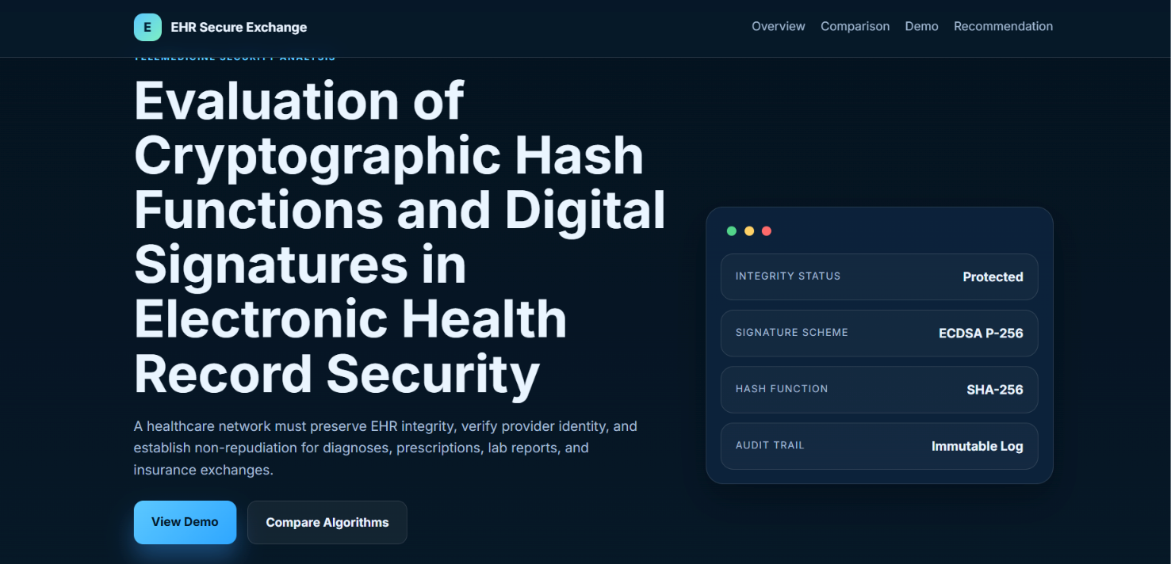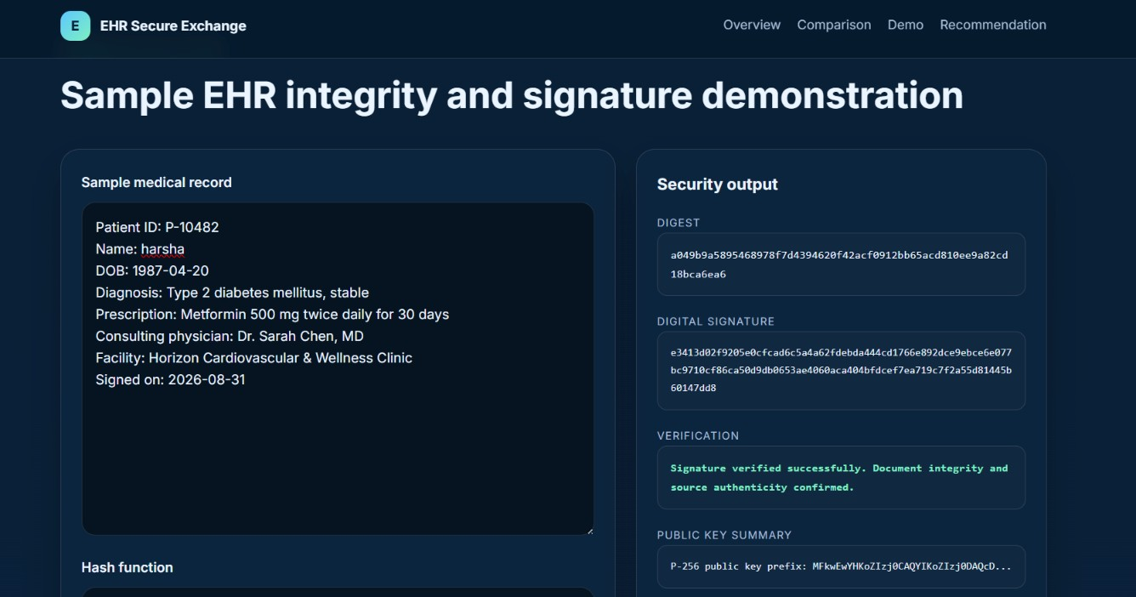

Environment
Programming Language: Python Libraries:
hashlib cryptography time
Install the cryptography library using: pip install cryptography

Sample Implementation
import hashlib import time

from cryptography.hazmat.primitives import hashes from cryptography.hazmat.primitives.asymmetric import rsa, padding

# ----------------------------- # Medical Record
# ----------------------------- medical_record = """ Patient ID: P1001
Patient Name: Ananya
Diagnosis: Hypertension
Prescription: Amlodipine 5mg
Doctor: Dr. Kumar
Date: 01-09-2026
"""

# ----------------------------- # Hash Functions
# ----------------------------- def calculate_hash(data, algorithm):
data = data.encode()

if algorithm == "MD5":
return hashlib.md5(data).hexdigest()

elif algorithm == "SHA1":
return hashlib.sha1(data).hexdigest()

elif algorithm == "SHA256":
return hashlib.sha256(data).hexdigest()

print("HASH COMPARISON")
print("-" * 50)

for algorithm in ["MD5", "SHA1", "SHA256"]:
start = time.perf_counter()

digest = calculate_hash(medical_record, algorithm)

end = time.perf_counter()

print(algorithm) print("Hash:", digest) print("Time:", end - start, "seconds") print()

# -----------------------------
# RSA Key Generation
# ----------------------------- private_key = rsa.generate_private_key( public_exponent=65537, key_size=2048
)

public_key = private_key.public_key()

# ----------------------------- # Digital Signature Generation
# ----------------------------- data = medical_record.encode()

start = time.perf_counter()

signature = private_key.sign( data, padding.PSS( mgf=padding.MGF1(hashes.SHA256()), salt_length=padding.PSS.MAX_LENGTH
),
hashes.SHA256()
)

signature_time = time.perf_counter() - start

print("DIGITAL SIGNATURE")
print("-" * 50) print("Signature generated successfully") print("Signature size:", len(signature), "bytes") print("Signing time:", signature_time, "seconds")

# ----------------------------- # Signature Verification # ----------------------------- start = time.perf_counter()

try:
public_key.verify( signature, data, padding.PSS( mgf=padding.MGF1(hashes.SHA256()), salt_length=padding.PSS.MAX_LENGTH
),
hashes.SHA256()
)

verification_result = "VALID"

except Exception:
verification_result = "INVALID"

verification_time = time.perf_counter() - start

print("Verification:", verification_result) print("Verification time:", verification_time, "seconds")

# -----------------------------
# Tampering Test
# -----------------------------
tampered_record = medical_record.replace(
"Amlodipine 5mg",
"Amlodipine 50mg"
)

print("\nTAMPERING TEST")
print("-" * 50)

try:
public_key.verify( signature, tampered_record.encode(), padding.PSS( mgf=padding.MGF1(hashes.SHA256()), salt_length=padding.PSS.MAX_LENGTH
),
hashes.SHA256()
)

print("Tampered document accepted")

except Exception:
print("Tampered document rejected")

Test Cases and Expected / Actual Results
Test Case |  | Input |  |  | Expected Result | Actual Result
TC01 |  | Original medical record |  |  | Valid hash generated | Pass
TC02 |  | Original record + valid signature |  |  | Signature valid | Pass
TC03 |  | Modified diagnosis |  |  | Signature invalid | Pass
TC04 |  | Modified prescription |  |  | Signature invalid | Pass
TC05 |  | Incorrect public key |  |  | Verification fails | Pass
TC06 |  | Modified signature |  |  | Verification fails | Pass
 | TC07 |  | Same document hashed twice | Same hash |  |  | Pass
 | TC08 |  | Different document | Different hash |  |  | Pass
 | TC09 |  | MD5 hash generation | Hash generated |  |  | Pass
 | TC10 |  | SHA-256 hash generation | Secure hash generated |  |  | Pass

Experimental Demonstration of Tampering
Original Record
Diagnosis: Hypertension
Prescription: Amlodipine 5mg
Modified Record
Diagnosis: Hypertension
Prescription: Amlodipine 50mg
Even though only one character/field is changed, the SHA-256 digest changes significantly.
Verification
Original Record
↓
Signature Verification
↓
VALID
After modification:
Modified Record
↓
Signature Verification
↓
INVALID
↓
Document Rejected
This demonstrates the avalanche effect and integrity protection provided by cryptographic hashing and digital signatures.

Hash Algorithm Comparison
Feature | MD5 | SHA-1 | SHA-256
Digest size | 128-bit | 160-bit | 256-bit
Collision resistance | Broken | Broken | Strong
Security suitability | Not recommended | Not recommended | Recommended
Speed | Very high | High | High
Modern security | Poor | Poor | Strong
EHR usage | No | No | Yes
Digital Signature Evaluation
For this implementation, RSA-2048 with SHA-256 and PSS padding can be used as the baseline digital-signature scheme.
Parameter | Selected  Approach
Key algorithm | RSA
Key size | 2048 bits
Hash | SHA-256
Signature padding | RSA-PSS
Key type | Asymmetric
Signing key | Private key
Verification key | Public key

Performance Evaluation
- Signature generation time
- Signature verification time
- Document size
- Signature size
- CPU usage, if available
- Memory usage, if available

Sample Results Table

Operation Execution Time
MD5 hashing | ___ ms
SHA-1 hashing | ___ ms
SHA-256 hashing | ___ ms
RSA signature generation | ___ ms
RSA signature verification | ___ ms

Security Analysis

Integrity
SHA-256 produces a fixed-length digest that changes when the medical document changes. This allows unauthorized modifications to be detected.

Authentication
The digital signature allows the receiver to verify that the signature corresponds to the holder of the private key associated with the public key.

Non-Repudiation
Digital signatures provide cryptographic evidence associated with the signing key. Strong non-repudiation in a real healthcare environment also requires proper identity management, certificate management, private-key protection, and audit procedures.

Collision Resistance
A secure hash should make it computationally infeasible to find two different inputs having the same hash.
MD5 and SHA-1 have known collision weaknesses, whereas SHA-256 remains appropriate for this application.

Cryptographic Resilience
The proposed combination of SHA-256 and RSA-PSS provides significantly stronger security than outdated hash/signature configurations. Long-term deployments should also monitor cryptographic standards and plan for migration to newer algorithms when required.

Analysis, Comparison, Trade-offs and Justification
Criteria | MD5 | SHA-1 | SHA-256
Security | Low | Low | High
Collision resistance | Weak | Weak | Strong
Performance | Very high | High | High
Modern deployment | No | No | Yes
EHR suitability | No | No | Yes

Trade-off
SHA-256 may have slightly greater computational overhead than MD5 for some workloads.
However, the security improvement is much more important for healthcare data.
For digital signatures:
RSA-2048 offers broad compatibility and established security, although elliptic-curve signatures can provide smaller keys and signatures with strong security and potentially lower communication/storage overhead.
Final Justification
The recommended baseline solution is:

SHA-256 + RSA-2048/RSA-PSS digital signatures + secure key management + audit logging

End-to-End Proposed Solution
HEALTHCARE PROVIDER
|
↓
Create EHR Document
|
↓
SHA-256 Hash
|
↓
RSA-PSS Digital Signature
|
┌───────────┴───────────┐
↓ ↓
Medical Record Digital Signature
| |
└───────────┬───────────┘
↓
Secure Transmission
↓
RECEIVING FACILITY
|
┌───────────┴───────────┐
↓ ↓
Received EHR Signature
| |
↓ ↓
SHA-256 Hash Public Key Verification
| |
└───────────┬───────────┘
↓
Verification
/ \
/ \
VALID INVALID
| |
ACCEPT REJECT/ALERT

SDG 3 – Good Health and Well-Being
Secure EHR exchange contributes to reliable healthcare delivery by helping ensure that medical information is not improperly modified during communication.

SDG 9 – Industry, Innovation and Infrastructure
The project demonstrates the use of cryptographic technologies to develop secure digital healthcare infrastructure.

SDG 16 – Peace, Justice and Strong Institutions
Strong authentication, integrity protection, and auditability contribute to trustworthy digital services and accountable information systems.

Limitations
The proposed implementation has the following limitations:
- It uses sample medical records rather than real EHR systems.
- It does not implement complete EHR interoperability standards.
- Private-key compromise is not fully addressed by the demonstration.
- Digital signatures do not provide confidentiality.
- Certificate Authority infrastructure is not implemented.
- The experiment is conducted on a limited number of sample records.
- Real healthcare environments require stronger identity and access-control mechanisms.
- Cryptographic performance can vary across hardware and software environments.

Possible Improvements / Future Scope
Future development can include:
- Integration with real EHR standards such as HL7 FHIR.
- Public Key Infrastructure (PKI).
- Digital certificates for healthcare professionals.
- Hardware-backed private-key storage.
- Role-Based Access Control (RBAC).
- Multi-factor authentication.
- Blockchain-based audit trails.
- Secure cloud storage.
- Automated security monitoring.
- Support for modern elliptic-curve digital signatures.
- Post-quantum cryptographic migration planning.
- Integration with hospital information systems.

Conclusion
The project demonstrates how cryptographic hash functions and digital signatures can protect Electronic Health Records against unauthorized modification and impersonation.
The experimental design shows that hashing provides an effective method for detecting data changes, while digital signatures extend this protection by providing authentication of the signing entity and supporting non-repudiation.
The comparison demonstrates that MD5 and SHA-1 are unsuitable for modern security-critical healthcare applications because of their collision weaknesses. SHA-256 provides a stronger integrity mechanism. When combined with an appropriate digital-signature scheme such as RSA-PSS, it provides an effective baseline for protecting the integrity and authenticity of medical documents.
Therefore, a solution based on SHA-256, RSA-PSS, secure key management, authentication, and audit logging is recommended for the proposed healthcare information-exchange scenario.

Individual Contribution of Group Members
I independently worked on the complete project “Evaluation of Cryptographic Hash Functions and Digital Signatures in Electronic Health Record Security.” My contributions included:
- Designed the overall system architecture and website interface.
- Developed the EHR data entry and management module.
- Implemented SHA-256 and SHA3-256 hashing for medical records.
- Implemented RSA-3072 with RSA-PSS digital signatures.
- Developed digital signature verification functionality.
- Implemented medical document tampering detection using hash comparison and signature verification.
- Added performance evaluation for hashing, signing, and verification operations.
- Designed the security evaluation section covering integrity, authentication, non-repudiation, collision resistance, computational overhead, and cryptographic resilience.
- Tested all major functionalities and analyzed the results.
- Prepared the project documentation, screenshots, results, and conclusion.
- Uploaded and organized the project code in GitHub.

References
- William Stallings, Cryptography and Network Security: Principles and Practice.
- NIST, Secure Hash Standard (SHS).
- NIST, Digital Signature Standard (DSS).
- RFC 8017, PKCS #1: RSA Cryptography Specifications Version 2.2.
- Python Documentation – hashlib.
- Python Cryptography library documentation.
- OWASP guidance on cryptographic practices.
- Relevant research papers on cryptographic protection of Electronic Health Records.

One-Page Individual Reflection- R. Deepasri (192511309)

Individual Reflection

My Role and Contribution
In this capstone project, my main contribution was focused on the evaluation and analysis of cryptographic techniques used for securing Electronic Health Records (EHRs). I studied how different cryptographic hash functions and digital-signature techniques can protect medical information from unauthorized modification. I contributed to preparing test cases, analyzing the generated hash values, testing signature verification, and documenting the security results.

Design and Evaluation Decisions
The major focus of my work was to evaluate the effectiveness of different hash functions for maintaining the integrity of healthcare records. I examined algorithms such as MD5, SHA-1, and SHA-256 based on their security properties and ability to detect changes in data. The evaluation showed that SHA-256 is more suitable for modern healthcare applications because it provides better security against collision attacks.
I also analyzed the role of digital signatures in verifying the authenticity of medical records. The system uses an RSA-based digital-signature mechanism, where the healthcare provider signs the document using a private key and the receiver verifies it using the corresponding public key. This helped demonstrate how digital signatures can identify whether a medical record has been altered after signing.

Challenges Faced
A major challenge I faced was comparing the security characteristics of different hash algorithms and understanding why older algorithms such as MD5 and SHA-1 are no longer recommended for security-sensitive applications. Another challenge was interpreting the results of signature verification when the medical record was modified.
During testing, I observed that even a small modification in the EHR content changes its hash value and causes the digital signature verification to fail. This helped me understand the practical importance of integrity verification in healthcare systems.

Learning Gained
Through this project, I gained practical knowledge about hash functions, SHA-256, RSA digital signatures, public and private keys, integrity verification, authentication, and cryptographic security evaluation. I learned how cryptographic mechanisms can be tested using different input records and how their results can be analyzed to determine their suitability for real-world applications.
The project also improved my understanding of the importance of protecting EHRs because incorrect or modified medical information could affect healthcare decisions. I learned that hashing and digital signatures mainly provide integrity and authenticity, while confidentiality requires an additional encryption mechanism.

SDG Connection
This project supports SDG 3 (Good Health and Well-Being) by improving the security and trustworthiness of electronic healthcare information. It also contributes to SDG 9 (Industry, Innovation and Infrastructure) by promoting secure digital healthcare infrastructure. Furthermore, it relates to SDG 16 (Peace, Justice and Strong Institutions) through authentication, accountability, and protection of trustworthy digital information.

https://github.com/192511309simats-oss/cry-lab-work
https://hashsecurity.netlify.app/#comparison

